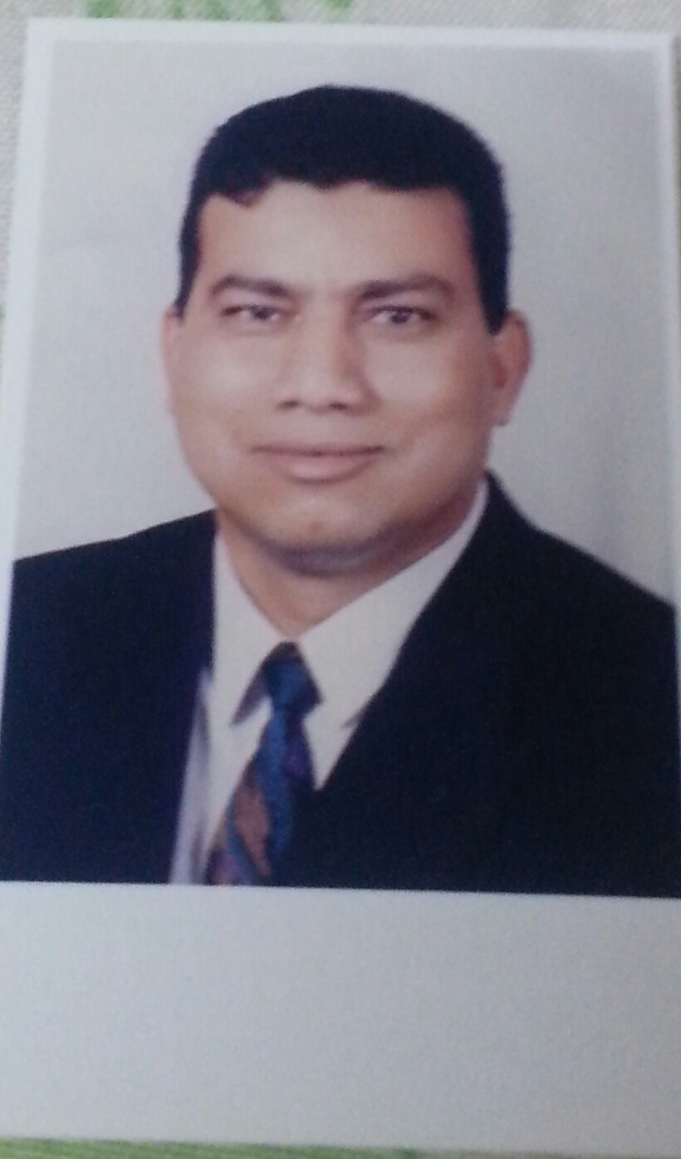
CURRICULUM VITA

Personal Information:

 | Assaf | Surname:
 | Kamal | First name:
 | Associated Professor | Position:
 | 01/10/1956 | Date of birth:
 | Sohag, Egypt | Place of birth:
 | Married ( Three children) | Status:
 | Friends Towers, Ferial Company, Egypt | Permanent address:
 | 0882321974  00201005291809 | Private office Tel.:  Mobil:
 | yehia1@aun.edu.eg kamal_assaf2000@yahoo.com | E-mail

ACADEMIC HISTORY:

- Bachelor of Engineering Science, Civil Engineer Department, Assiut University, June 1979.
- Master of Science in sanitary Engineering, Assiut University, April 1986.
- Doctor of Philosophy in Structural Engineering, Moscow, M.A.D.E Institute, USSR, March 1994.

Career

- Administrator at Civil Eng. Dept., Faculty of Eng., Assiut University, from 1979 to 1986.
- Assistant Lecture at Civil Eng. Dept., Faculty of Eng., Assiut University, from 1986 to 8/5/1990.
- Scholarship to study PHD at Moscow, M.A.D.E Institute, USSR, 1990 to 1994.
- Lecture at Civil Eng. Dept., Faculty of Eng., Assiut University, from 1994 to 2001.
- Assistant professor at Civil Eng. Dept., Faculty of Eng., Assiut University, from 2001 to now.
- Member of the jury of Journal of Engineering Sciences Assiut University, Faculty of Engineering.
- University, Faculty of Engineering.

Teaching experience

- Assistance in teaching reinforced concrete structures, theory of structures and properties of materials courses from 1979 to 1994.
- Lecture in of reinforced concrete structures , properties of materials , Theory of Structure and Construction Management courses from 1994 to now
- Supervisor of reinforce concrete structures project at faculties of engineering in Assiut university.

Practical experience

- Consultant engineer in design of reinforced concrete structures.
- Consultant engineer in Quality Control and Constructions Testing.
- Reference engineer in Egyptian combined civil liability insurance.
- Certified consultant engineer at new urban community’s authority, Ministry of Housing, Utilities and New Urban Communities, Egypt.
- Member in center of studies and engineering consultants, faculty of engineering, Assiut University.
- Director of center of engineering consultants and designs, special office, from July 1997 until now.
- Consultant engineer at General Authority for Educational Buildings, Sohag branch from July 1996 to July 2000.
- Advisor Engineering for Sohag University from 2012 to now.

Foreign languages

- Good English writing and speaking.
- Speaking Russian language.

PRIZES:

Holds the prize of the best research at Civil engineer department from Assiut University at 2001.

Publications

- The Effect of Incorporation of Ferrite Nanoparticles on Compressive Strength and Resistivity of Self-Compacting Concrete, Open Journal of Civil Engineering, page 131-138, Volume 5, March 2015.
- Fascinating Improvement in Mechanical Properties of Cement Mortar using Multiwalled Carbon Nanotubes and Ferrite, International Journal Structural and Civil Engineering research, Vol. 4, No. 1, February 2015.
- Nanoparticles Improvement of performance of R.C beams made from RCA by sing non tradional admixture ICCCGE , Toronto, Canada, June 16-17-2014.
- Improvement of concrete properties made from RCA using non tradional admixture Journal of Engineering Science, Assiut University pp. 303-316, Vol. 42, March 2014.
- Influence of size and replacement ratio of RCA on concrete properties, Journal of Engineering Science, Assiut University pp. 50-63, Vol. 42, January 2014.
- Flexural behavior of strengthened and repaired R.C. beams by using steel fiber concrete jacket and under repeated load, International Journal of Civil and Structural Engineering, P. 564-578, Vol. No. 3, March 2013.
- Prediction of Shear Strength of High strength reinforced concrete Tee Beams, JES Journal of Engineering Sciences-Assiut University, pp. 29-52, Vol. No. 35, January 2007.
- Shear Response of Large R.C beams provided with side bars under repeated loading, JES Journal of Engineering Sciences-Assiut University, pp. 1113-1131, Vol. No. 4, July 2006.
- Flexural behaviour of lapped spliced high strength R.C beams subjected to static loading, JES Journal of Engineering Sciences-Assiut University, pp. 395-411, Vol. No. 34, March 2006.
- Improvement of Deformability of High Strength Beams of Over Reinforcement Section, JES Journal of Engineering Sciences-Assiut University, pp. 387-401, Vol.30, April 2002.
- Behaviour of R.C Beams Strengthened by CFRP laminates Subjected to Short Time Dynamic Loading, SEMC 2001- University of Cape Town - South Africa, 2001.
- Improvement Behaviour of R.C beams subjected to Static Loading by Confinement of Compression Zone, Journal of Engineering Sciences-Assiut University, pp. 43-53, Vol. 28, May 2000.
- Behaviour of R.C Beams Reinforcing with Epoxy Coated Bars under Repeated Loads, The Second Egyptian Conference on Earthquake Engineering, pp. 271 -283, Vol. 1, Nov. 1997.

Participation in scientific conferences

- Eleventh Colloquium on Structural and Geotechnical engineering; Ain shams University, Cairo, Egypt, May 2005.
- First International conference of Civil Engineering Science, Assiut, Egypt October 2003.
- Tenth Colloquium Structural and Geotechnical engineering, Ain shams University, Cairo, Egypt, June 2003.
- Arabic Building materials and Economical challenges Conference, Cairo, Egypt, April 2000.
- Fifth International conference, Al-Azhar University, Cairo, Egypt, December 1997.
- The Second Egyptian Conference on Earthquake Engineering, Aswan, Egypt, November 1997.
- Second International Conference on Engineering Researches, Port said University, Egypt, December 1995.

Supervision of Thesis

- Eng. Khaled Abdel-Samie Abdel-Mohsen, Assistant lecturer.

Degree | PHD
Title | Improvement of Fresh and Hardened Concrete Properties Fabricated from Recycled Aggregate
University | Assiut
Faculty | Engineering
Department | Civil
Date of award | June 2015

- Eng. Khaled Abdel-Samie Abdel - Mohsen, Manger of sites in Sohag housing and building organization.
Degree | MSC
Title | Shear Behaviour of R.C Tee Beams (Theoretical Approach)
University | Assiut
Faculty | Engineering
Department | Civil
Date of award | March 2007

Shortlist of Consultant Works:

- Design building of El-Ibrahemea towers at Assiut city which contain five towers and 196 apartments.
- Design building of El-Moalah towers at Assiut city which contain ten towers and 256 apartments.
- Design of building El-Ard El-Mlab towers at Assiut city which contain five towers and 240 apartments.
- Design building of Faculty engineering at Sohag University, El-kwamal campus.
- Design building of Faculty education at Sohag University, El-kwamal campus.
- Design building of Faculty arts at Sohag University, El-kwamal campus.
- Design building of Faculty agriculture at Sohag University, El-kwamal campus.
- Design building of Faculty veterinary at Sohag University, El-kwamal campus.
- Design building of staff members of Sohag University, El-kwamal campus which contain eleven towers and 342 apartments.
- Design of the structures of road between New Sohag and Sohag City which contain design of four reinforced concrete bridges, culvert and two reinforced concrete pipes bridges.
- Prepare many numbers of reports of preview of many structures in Upper Egypt.
- Prepare many numbers of reports for tests of reinforced concrete materials.

